INOVA WEB APPLICATION TESTING PROCESS ATTENDANCE MODULE
1. Attendance> Shift Definition: - Working
I have added the shift but not confirmed. The problem is attendance rule details are not showing, but attendance rule detail data is available. Please check.
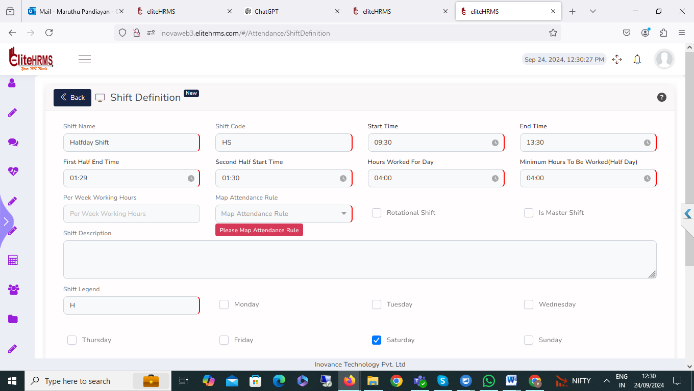
2. Attendance>Attendance Rules: - Pending
Note Edit Is not Working
Attendance rule details I can't create the reason is mandatory details are not visible; please check.

Attendance rule details have been added; working is fine. The problem is I have edited the innova attr rule, but the display view test updated devtestt rule edit options are mismatched. Please check the issue.
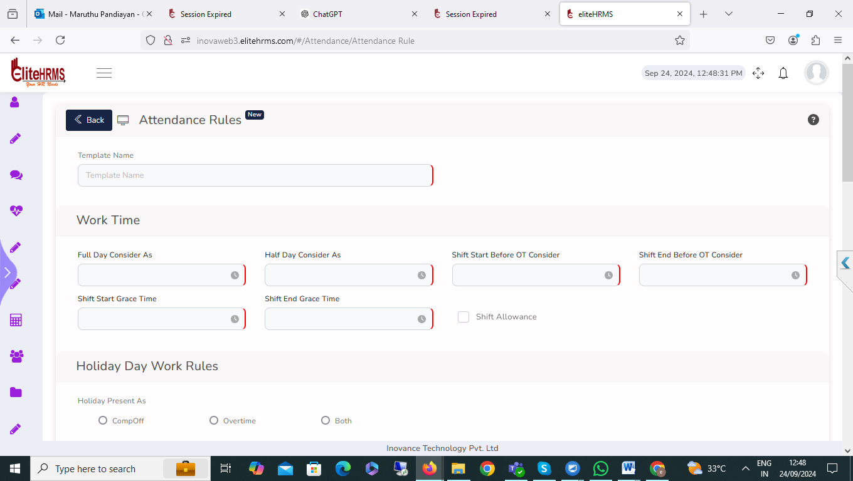
3. Attendance> Map Employees – Completed
Map Employees options are working fine. No issue
4. Attendance> On Duty: - Completed
On-duty entry options are working fine. My suggestion is that the On Duty Status and cancel options are enabled.
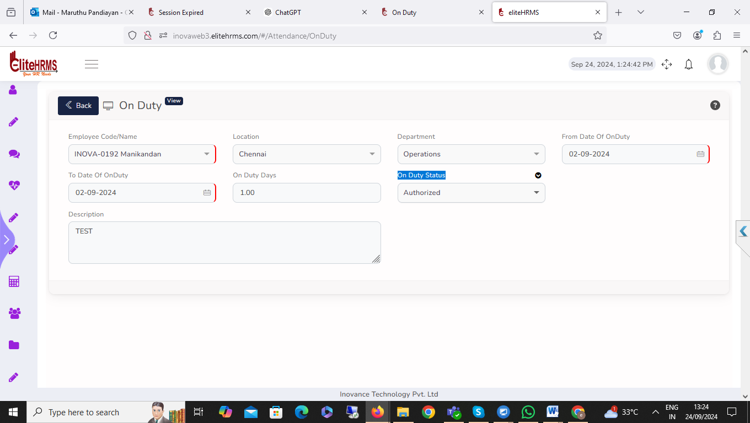

5. Attendance> Hourly On Duty: - Completed
1. Hourly On-duty entry options are working fine. My suggestion is that the On Duty Status and cancel options are enabled.
2. Hourly On-duty report row number order by mistakenly. Please check – More Clarafication Need
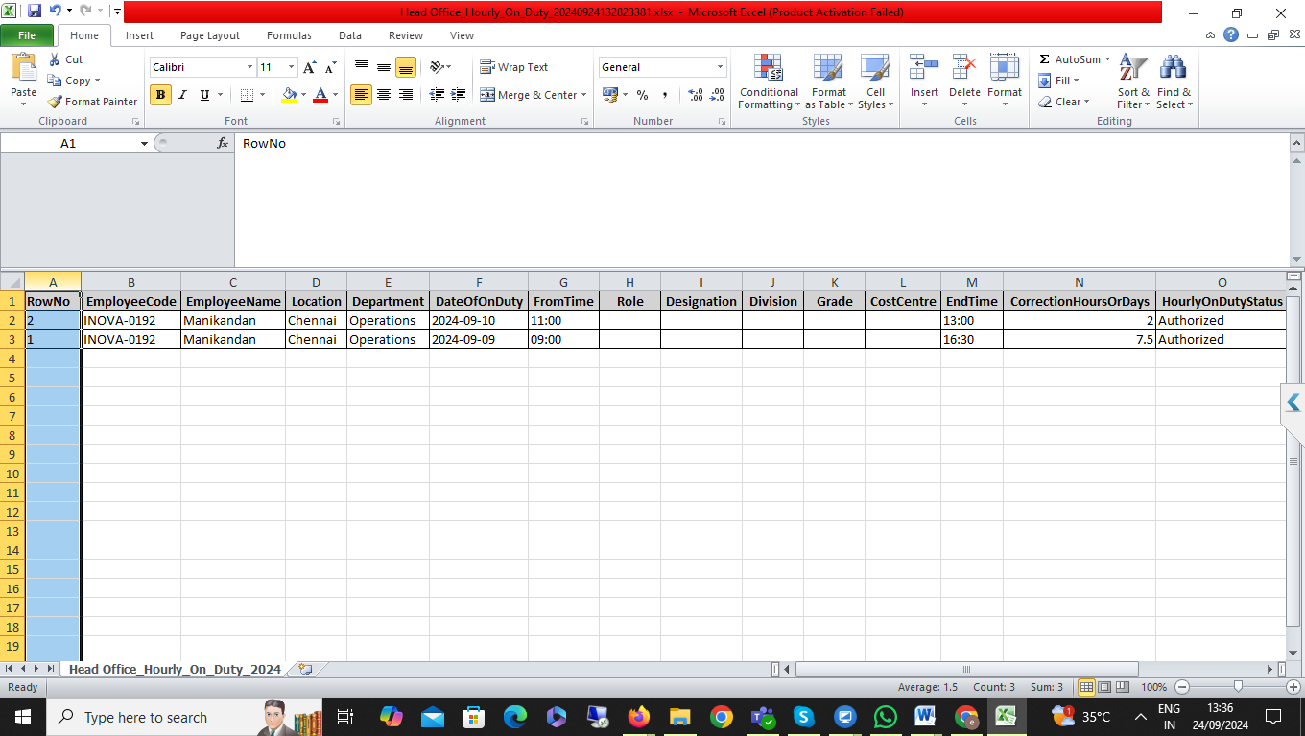
6. Attendance>Manual punch: - Pending
Attendance Manual Punch Screen shift name details are not showing. Related manual punch details not entry, please check.
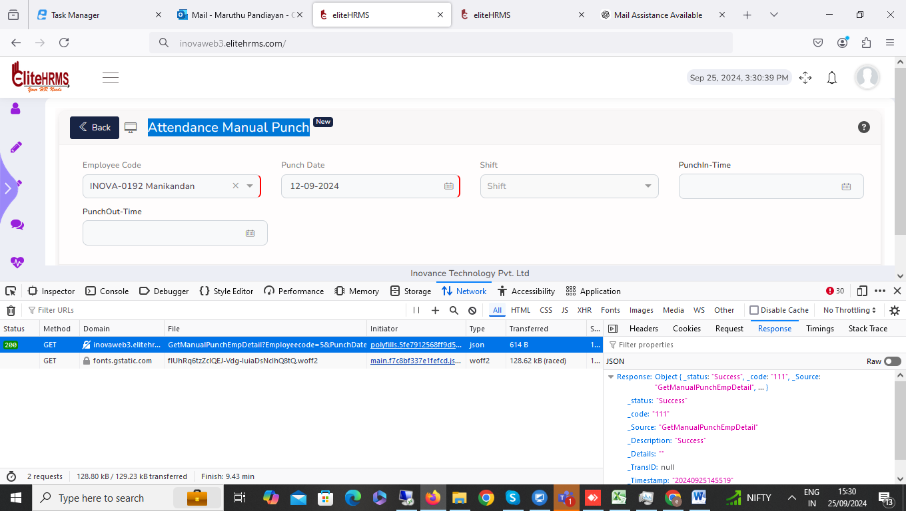
7. Attendance> Shift Roaster: - pending
Attendance Shift roaster details Department and division details filter options are not working. Please check.

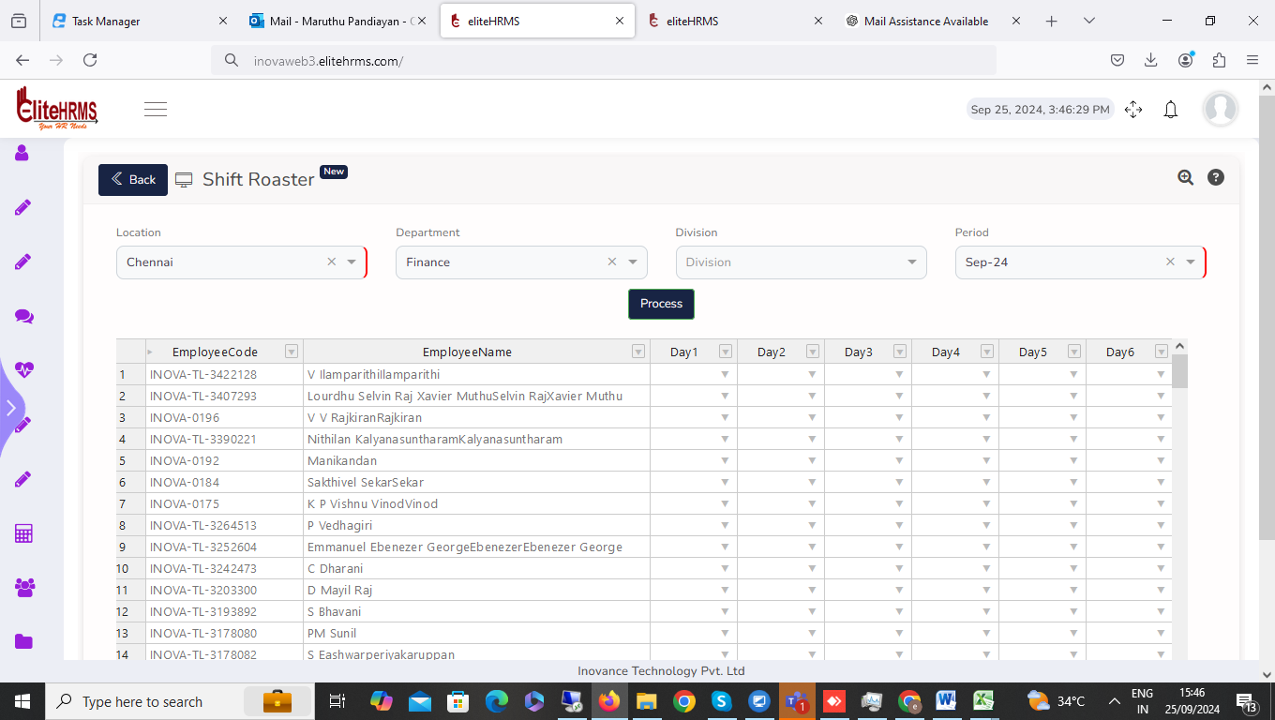

8. Attendance> Shift Roaster: - pending
Attendance shift roaster details for the month of August have already been updated; multiple records for the same month are permissible. Not displaying the error notice.
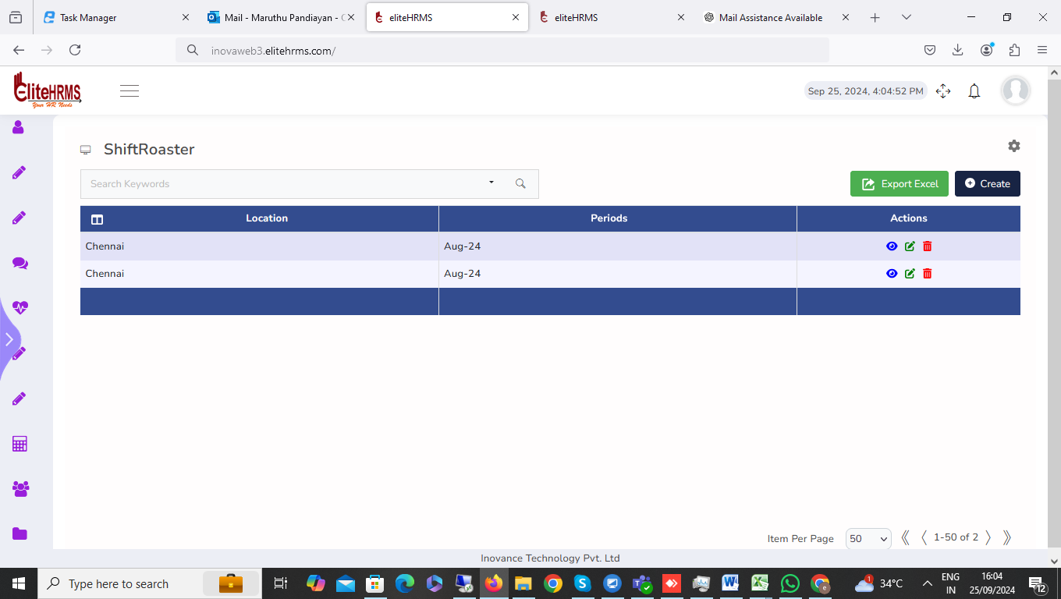
9. Attendance> Shift Roaster: - pending
I have deleted the August month duplicate entry delete button click. but an error message showed; please check.
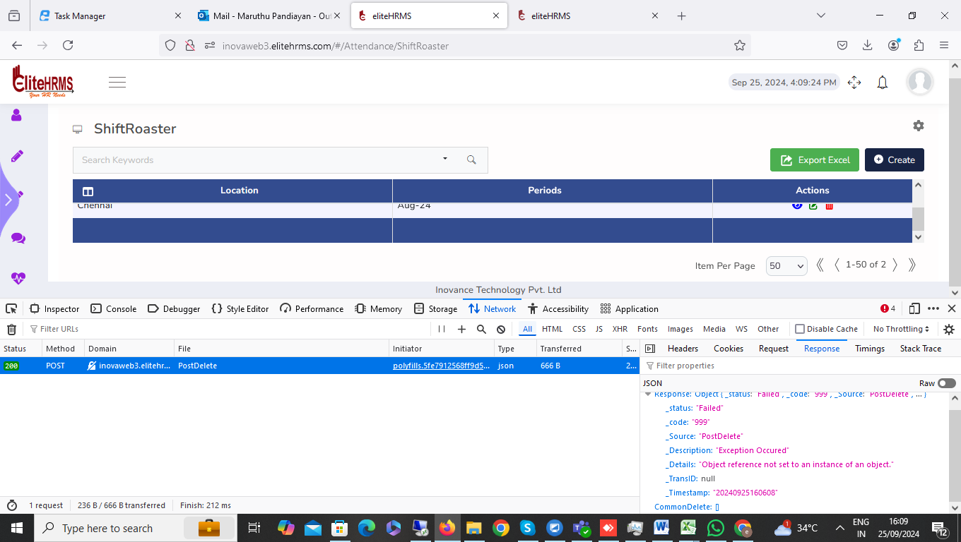
Response | Object { _status: "Failed", _code: "999", _Source: "PostDelete", … }
_status | "Failed"
_code | "999"
_Source | "PostDelete"
_Description | "Exception Occured"
_Details | "Object reference not set to an instance of an object."
_TransID | null
_Timestamp | "20240925160608"
CommonDelete | []

10. Attendance> Shift Roaster: - Working
Only 30 days of the 31-day month are displayed for the shift roaster details upload sheet. Please check

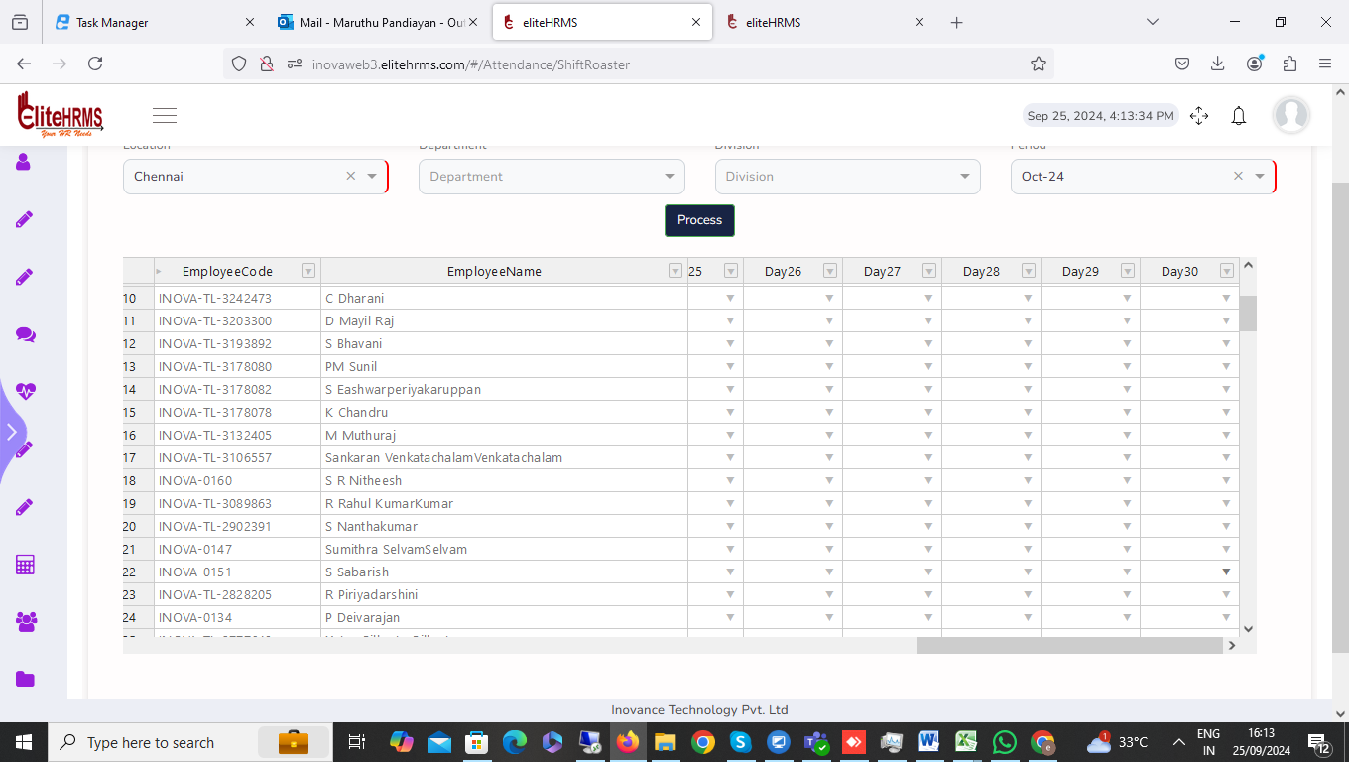.

11. Attendance> Shift Change: - pending
I have checked the shift change entry screen is working fine; employee code selected department and location name details are not visible date options. Select the department and location details visible; please change the options.
12. Attendance>Shift Change Upload: pending
I have the shift change details sheet loaded and the upload button clicked, but no response. Please check.
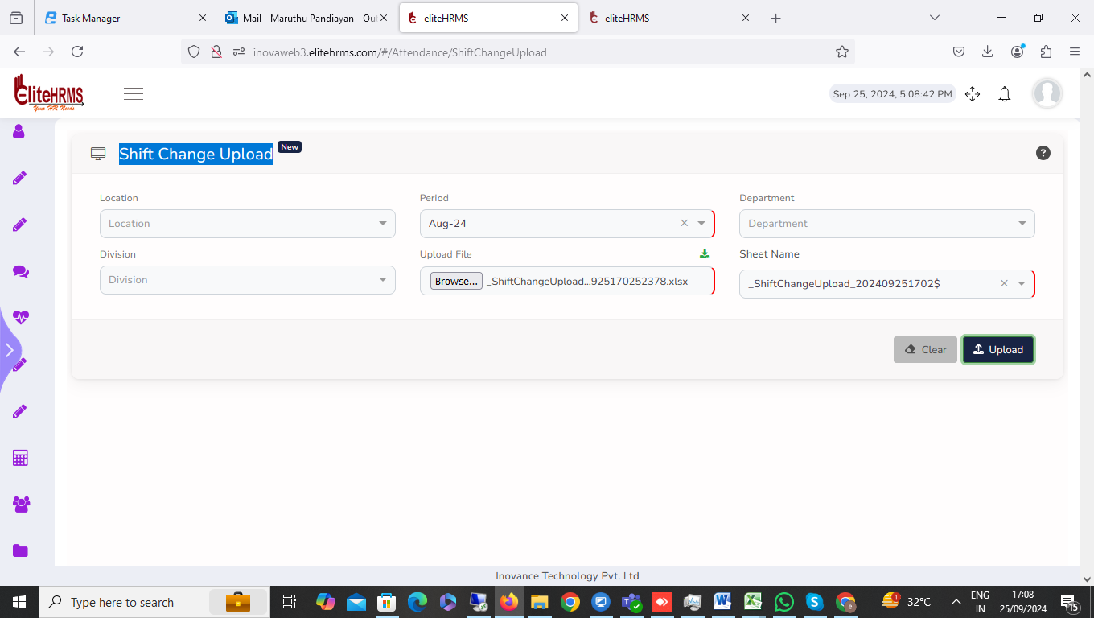
13. Attendance>Attendance Leave: - Pending
* I encountered an issue in the system where an employee's Earned Leave (EL) and Privilege Leave (PL) balances are zero, but the attendance leave entry is still being accepted for this employee. Please check the system and resolve this issue, ensuring that leave entries are not accepted when the available leave balance is zero.
* I have encountered an issue when clicking the Edit button in the Leave Entry section. The date column is showing "Invalid Date"
* I have noticed an issue with an employee's leave entry where the same date has been entered twice—one as a full day and the second as a half day. This should be an invalid process, but no error message is displayed to prevent the duplicate or conflicting entry. Please check and resolve this issue so that the system displays an error message in such cases, preventing invalid leave entries?
* I have encountered an issue with an employee's Casual Leave (CL) balance. Although the leave balance is available, I entered one day of CL, but the system did not deduct the leave balance as expected.

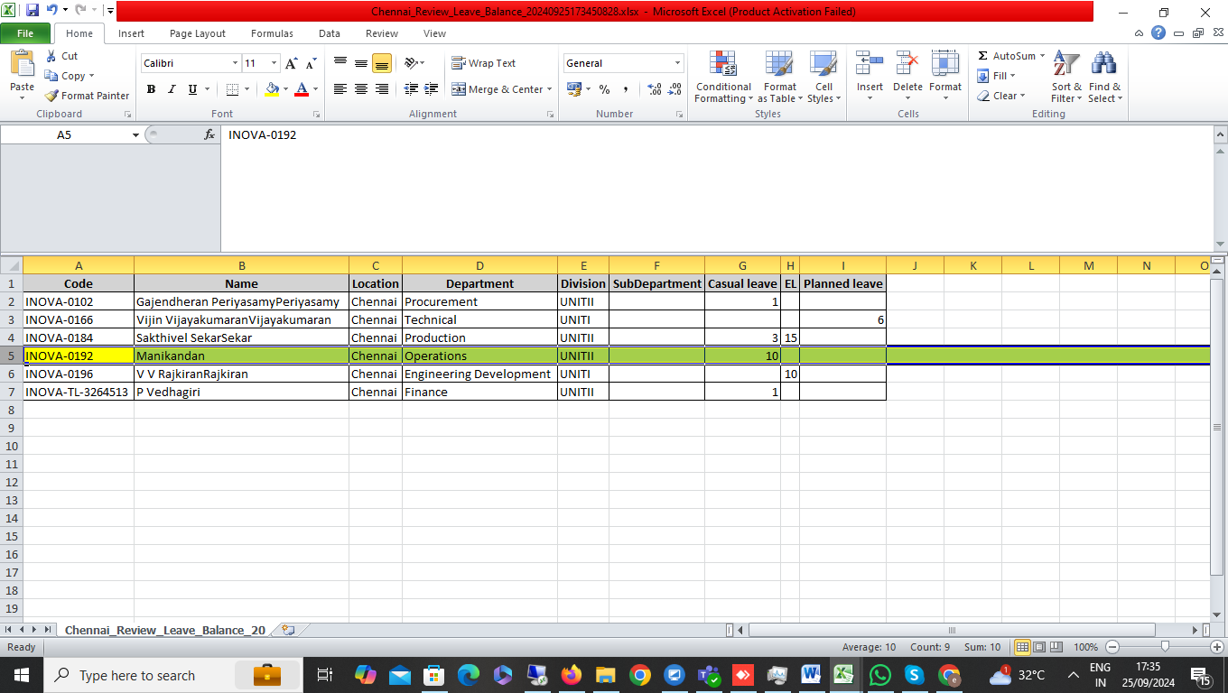

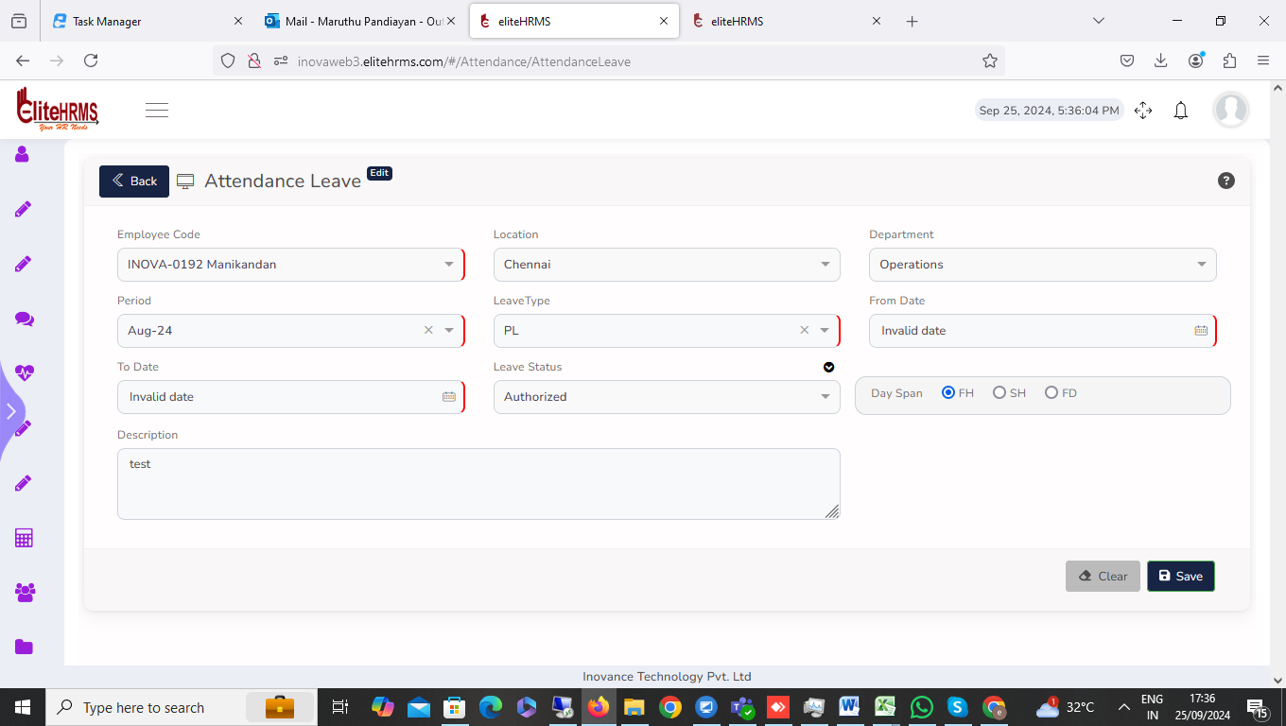

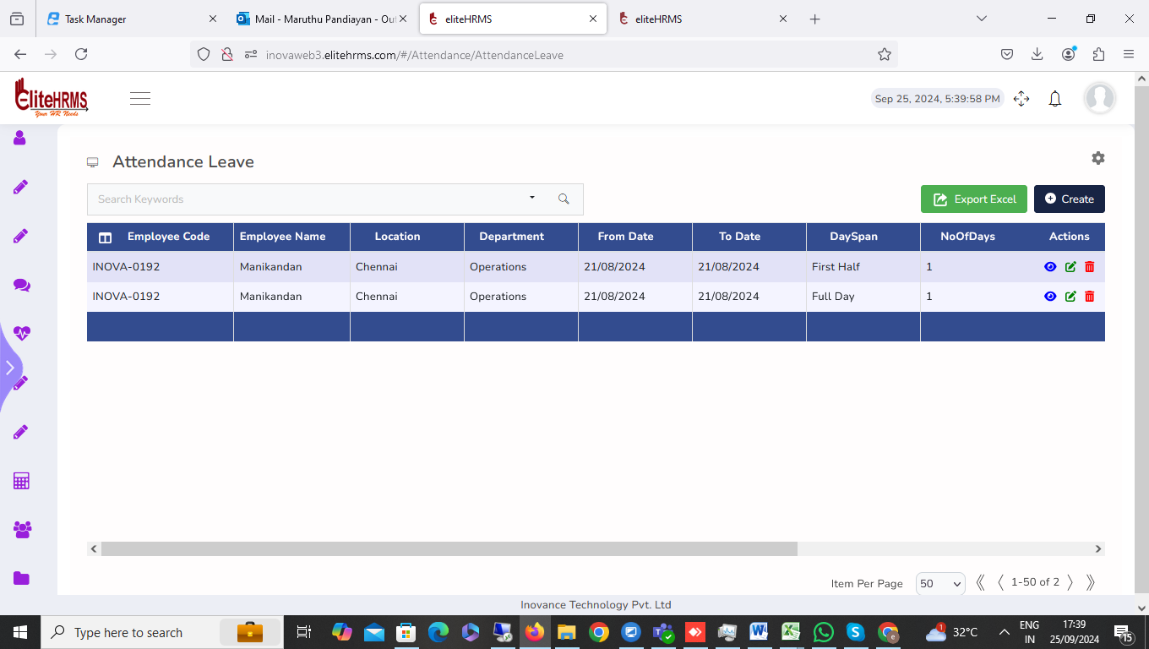
14. Attendance>Permission: - pending
* The permission entry screen is functioning properly, but I have encountered an issue with the attendance rule for permission. The system is configured to allow a maximum of 2 hours, but I was able to enter a timing exceeding 2 hours, and it was accepted without any restriction. Please check and resolve this issue so that the system enforces the maximum limit of 2 hours for permission entire.
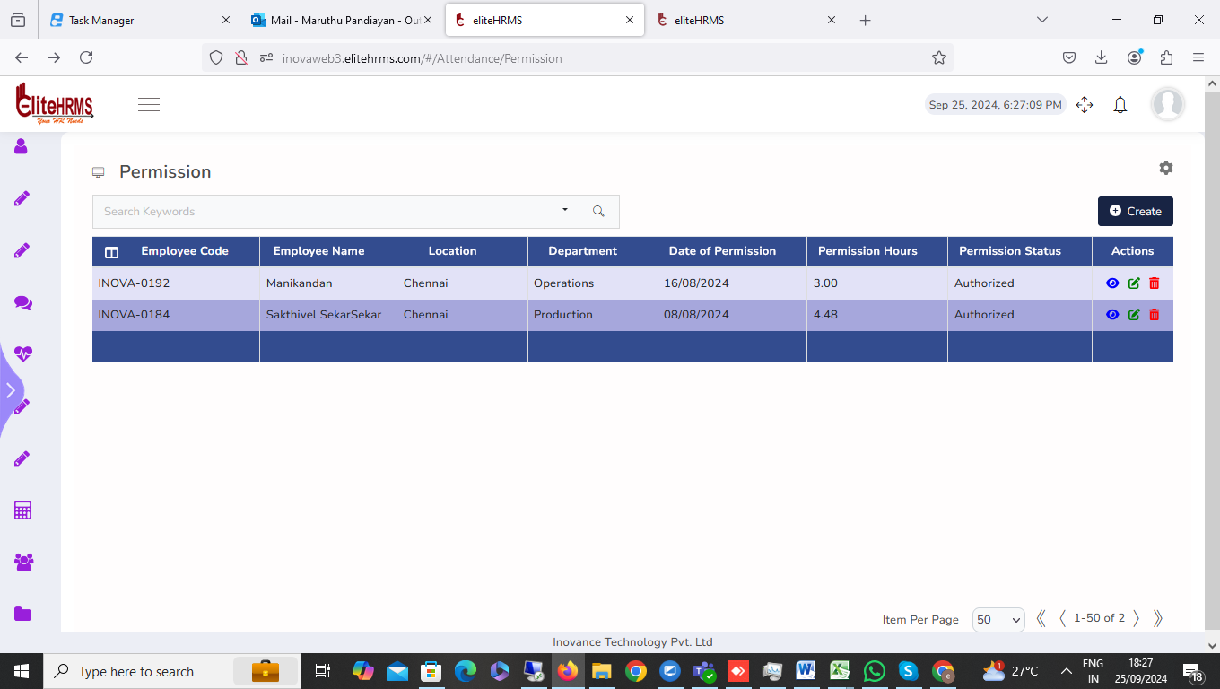
- The permission search page position status, service position status, and permission status details dropdown are not visible
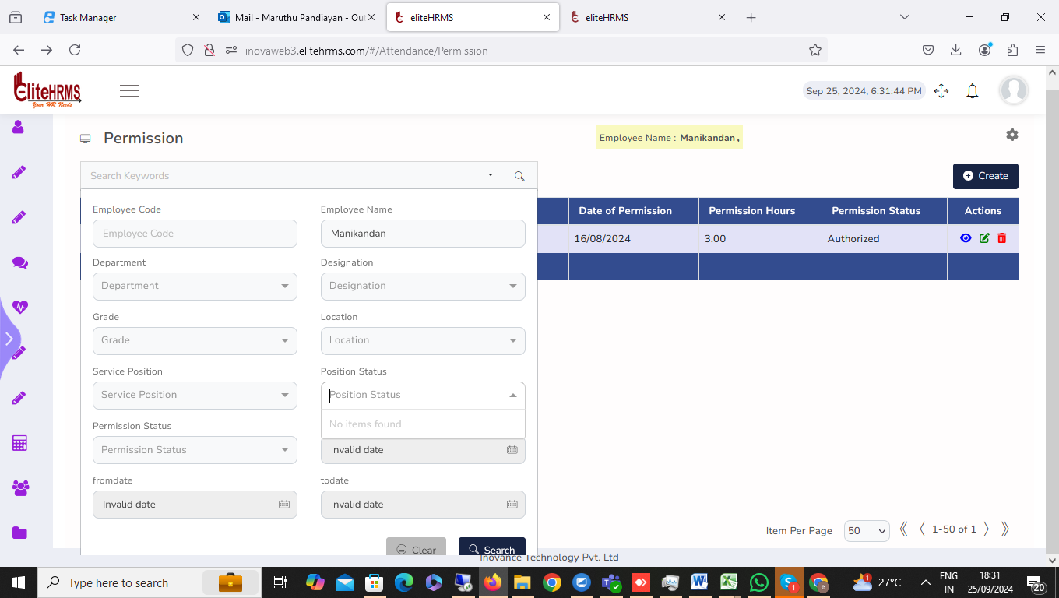
15. Attendance> CompoffRequest: - More Clarification
The CompoffRequest entry screen is functioning properly. C-Off balances are zero, but the CompoffRequest entry is still being accepted for this employee. Please check
16. Attendance> Success Process: No Need
Leave Post options for the attendance process were clicked to display the error message. Please check.
Attendance report data details not visible.
17. Attendance> Success Process:
I need some clarification on how to run the Success Process on the front end. Specifically, I would appreciate it if you could explain the following details:
- Process Execution: How to initiate the process from the front end.
- Configuration Settings: Any specific configurations or settings that need to be applied.
- Stored Procedure (SP) Name: If a stored procedure is involved, could you please provide the SP name and details on how it interacts with the process.

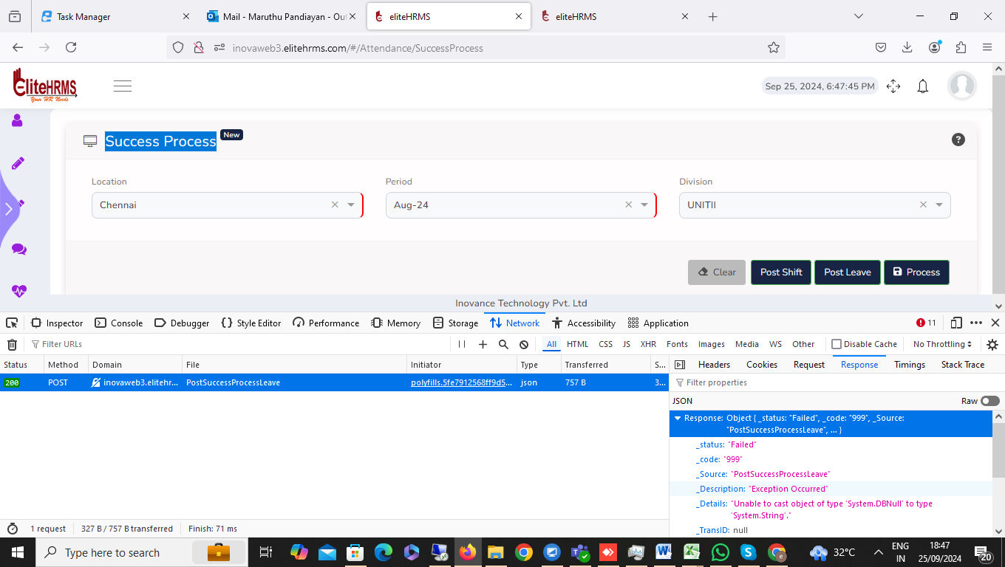
18. Attendance> Attendance Log: pending
I encountered an issue when accessing the attendance log screen. Upon clicking the screen, an error message was displayed. Please check and resolve this issue.
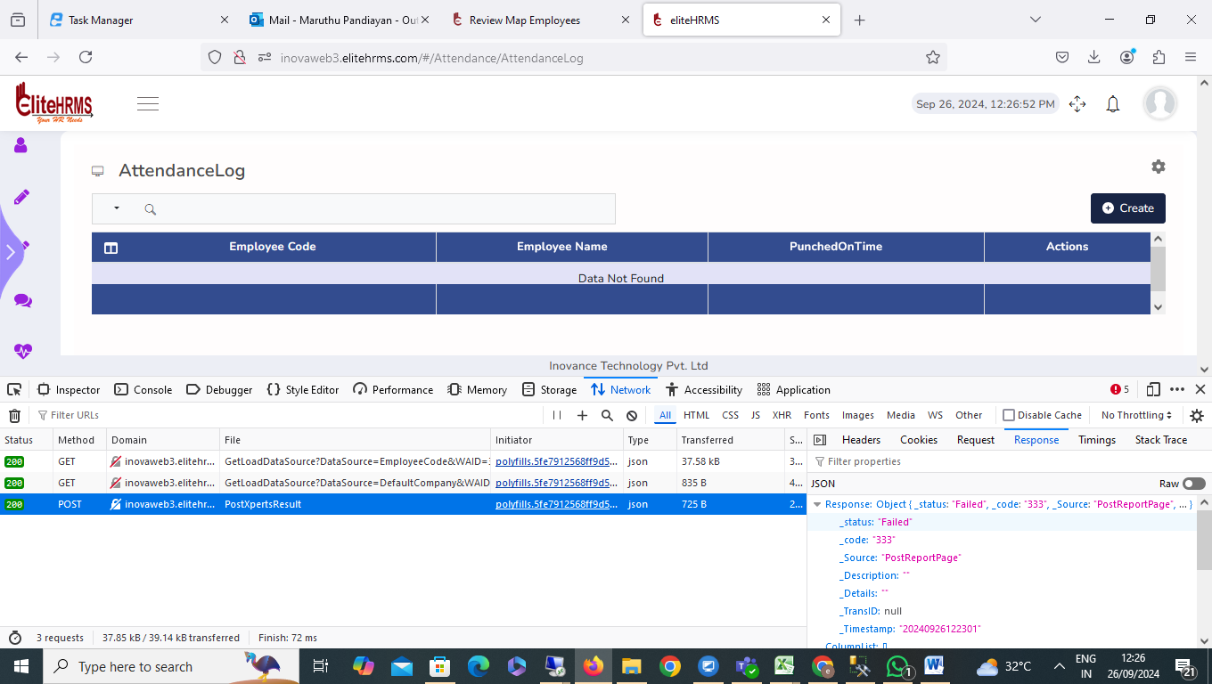
Response | Object { _status: "Failed", _code: "333", _Source: "PostReportPage", … }
_status | "Failed"
_code | "333"
_Source | "PostReportPage"
_Description | ""
_Details | ""
_TransID | null
_Timestamp | "20240926122301"
ColumnList | []
PageGridResultJson | []
PageGridResult | []
pageInfo | Object { TotalPageCount: null, PageNo: null, PageSortBy: null, … }
TotalPageCount | null
PageNo | null
PageSortBy | null
PageSize | null

19. Attendance>Review Attendance Log: pending

Review Attendance Log report from date and to date filter options are not working; please check.
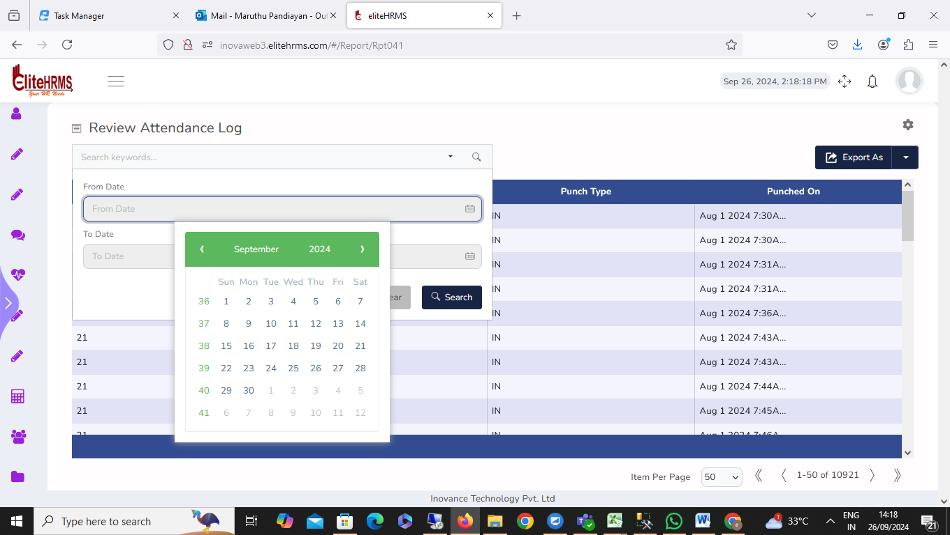

20. Attendance> Review Monthly Present Summary: pending

* Review Monthly Present Summary report all filter options and report excel export not working, please check.
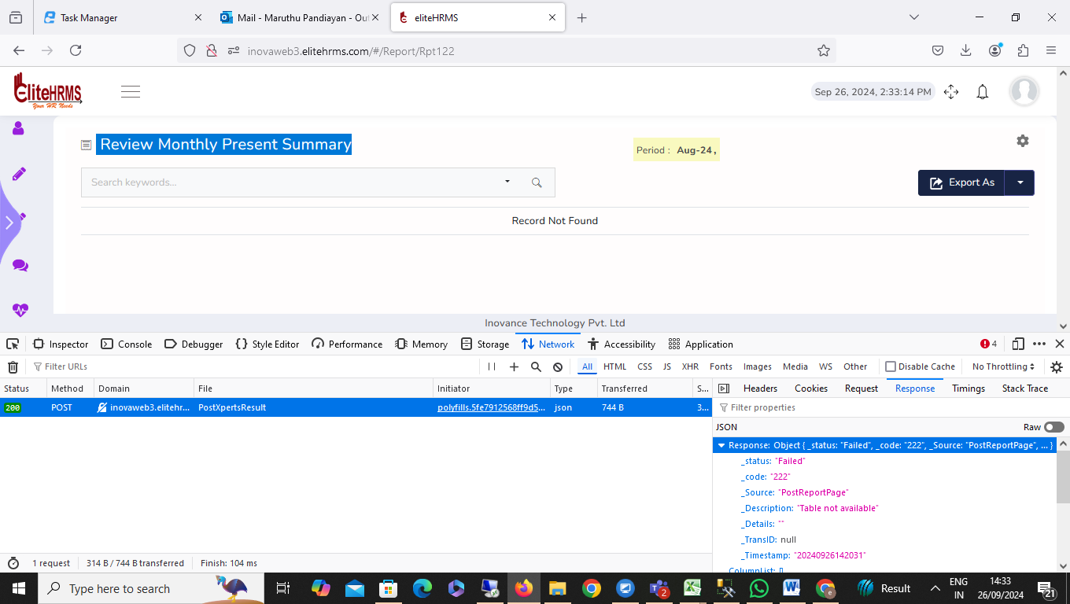

21. Attendance> Review Monthly Status: pending

Review Monthly Status report all filter options and report excel export not working, please check.
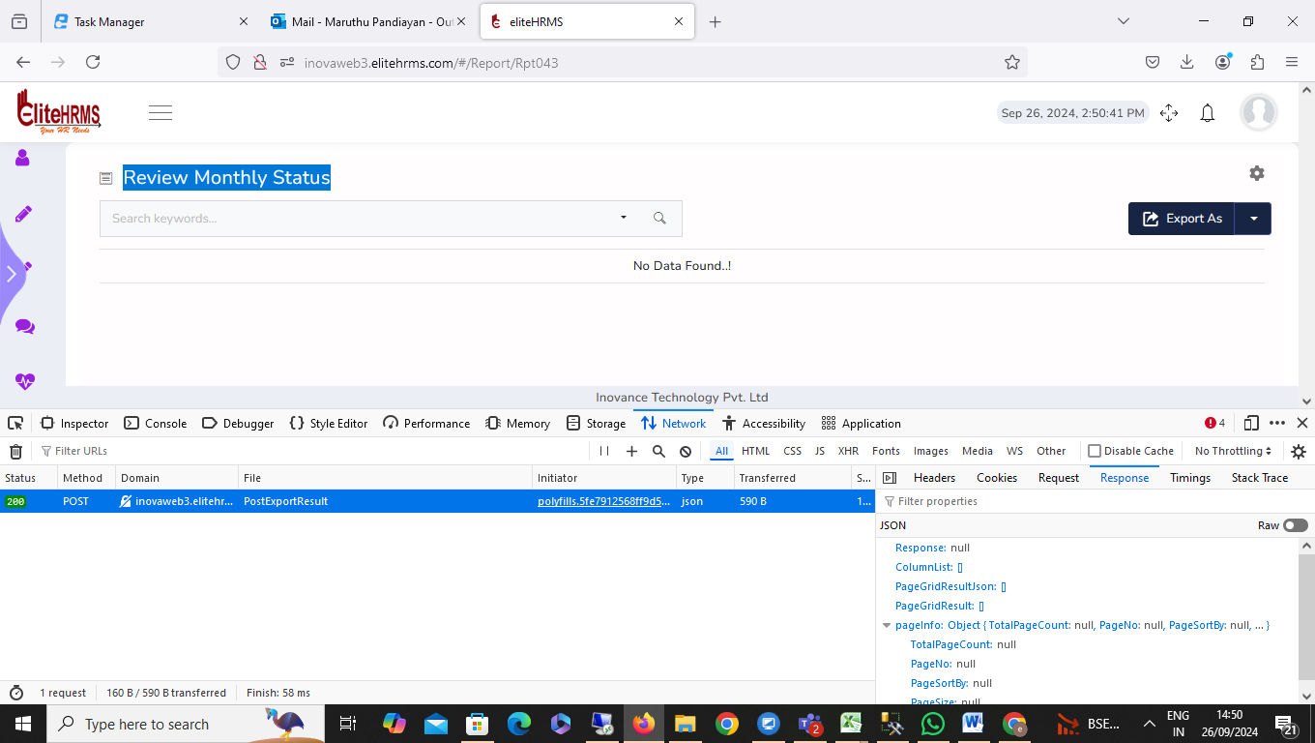
22. Attendance> Review Shift: Completed
Review Shift options are working fine. No issue
23. Attendance> Review Shift Roster: Completed
Review Shift Roster options are working fine. No issue
24. Attendance> Manual Punch: Completed
Manual Punch options are not working.
25. Attendance> Hourly On Duty: Completed
Hourly on Duty view page location, department Unit Service Position Position Status details not visible.
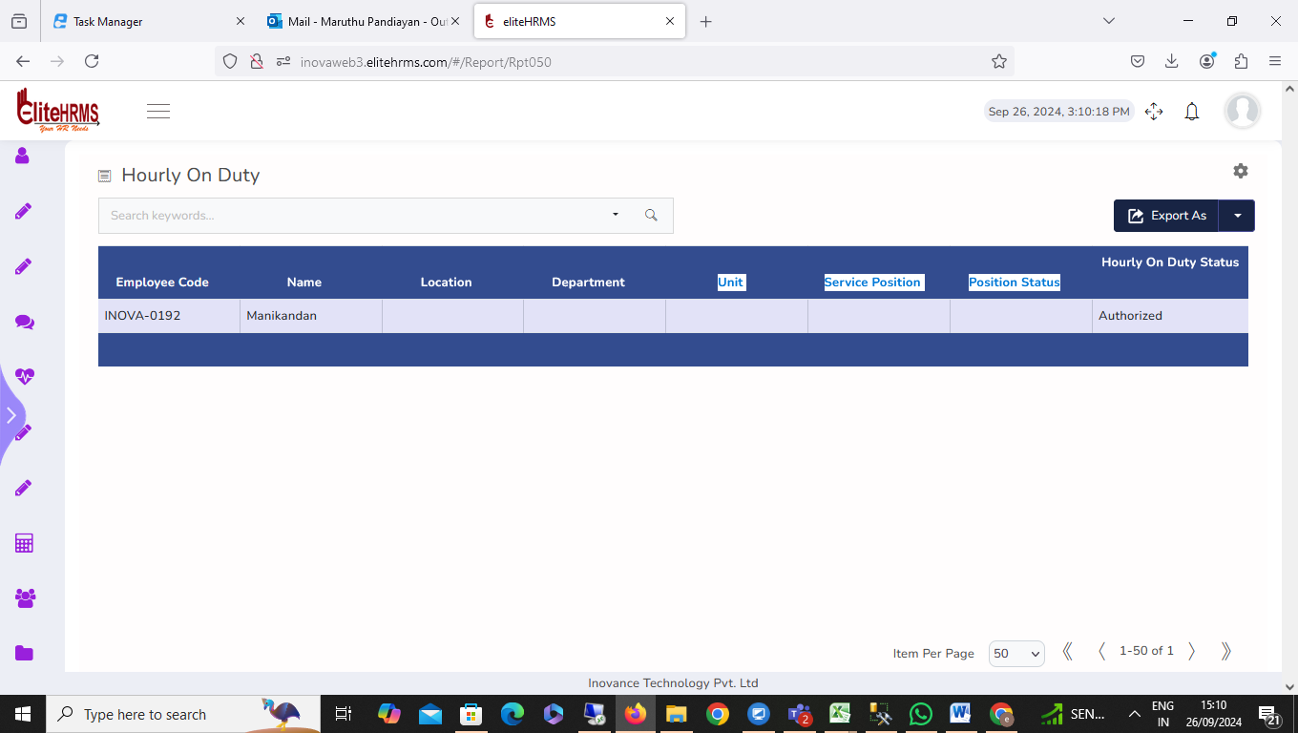
26. Attendance> Review On Duty: pending
Review on Duty on Duty Status details not visible.

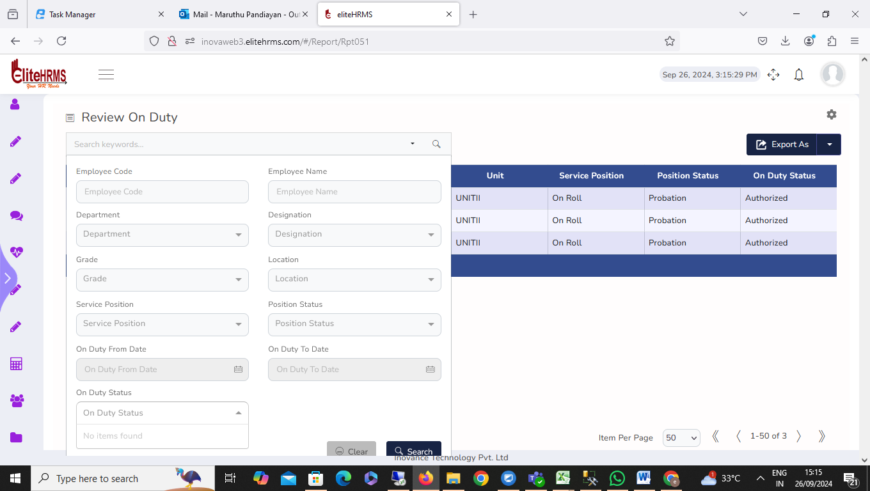
27. Attendance>Review Attendance Register: pending
Review Attendance Register report not working, please check.
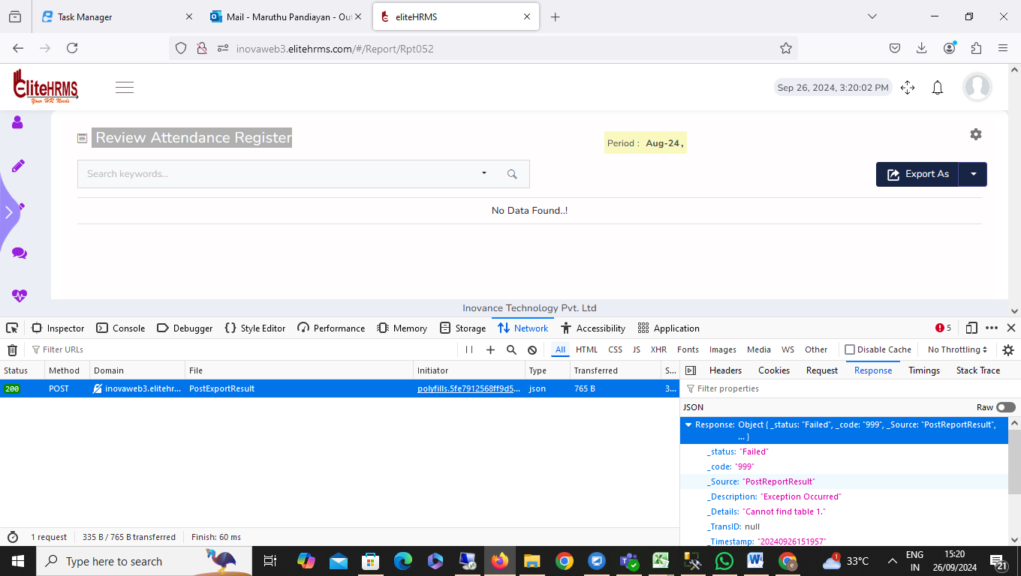
28. Attendance> Review Attendance Leave: -pending
Review Attendance Leave report from date, to date, leave status, leave type filter options are not working; please check.
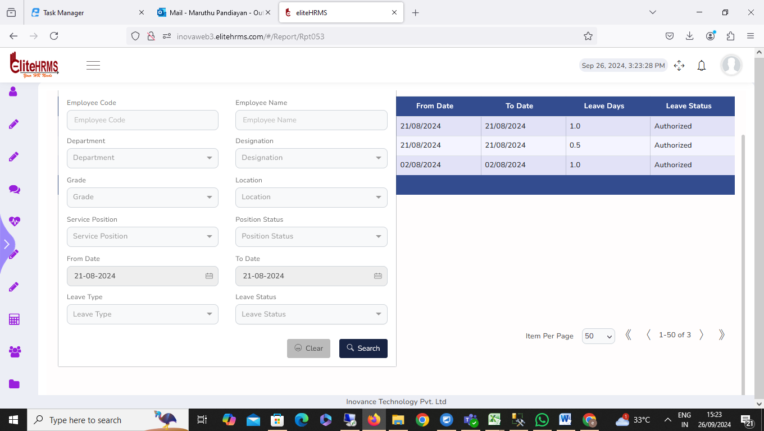
29. Attendance> Review Shift Change: pending
Review Shift Change report not working, please check
30. Attendance> Review Geo Punch: pending
Review Geo Punch view page Employee code, Employee name, shift, location Status details not visible.
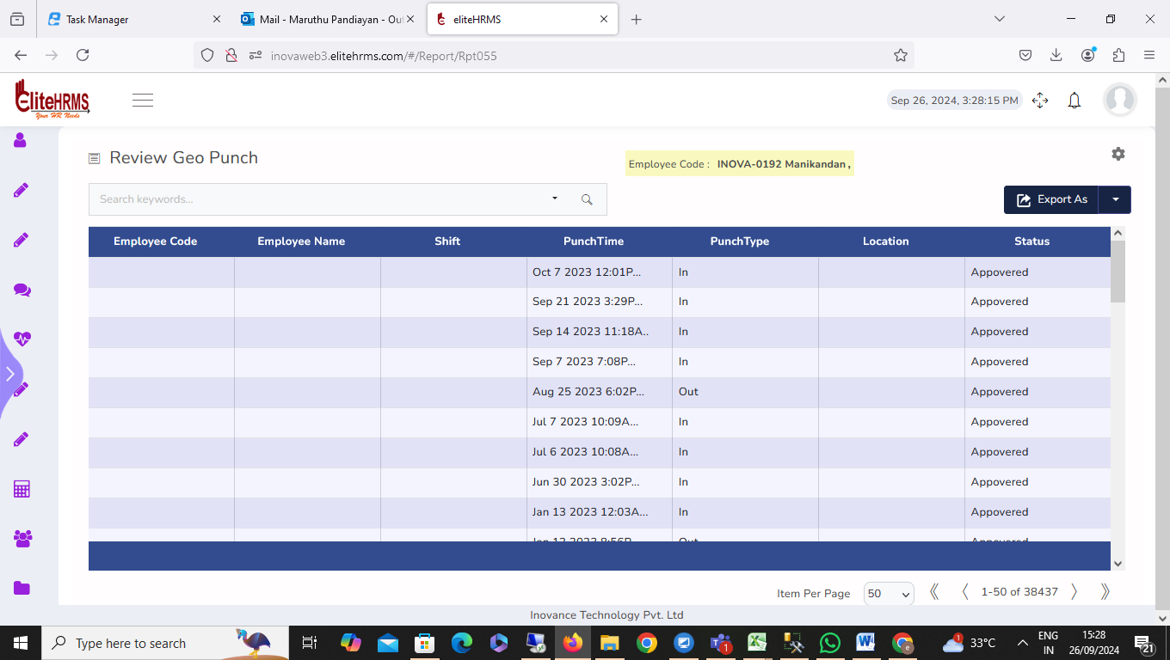
31. Attendance>Review Leave Balance: completed
Review Leave Balance options are working fine. No issue
32. Attendance>Review Permission:pending
Review permission options. Clicked automatically application log out, please check.

